Step by Step process for ordering Graduate Regalia from the
Penn State Great Valley Bookstore

- Go to our University Bookstore web site: psu.bncollege.com

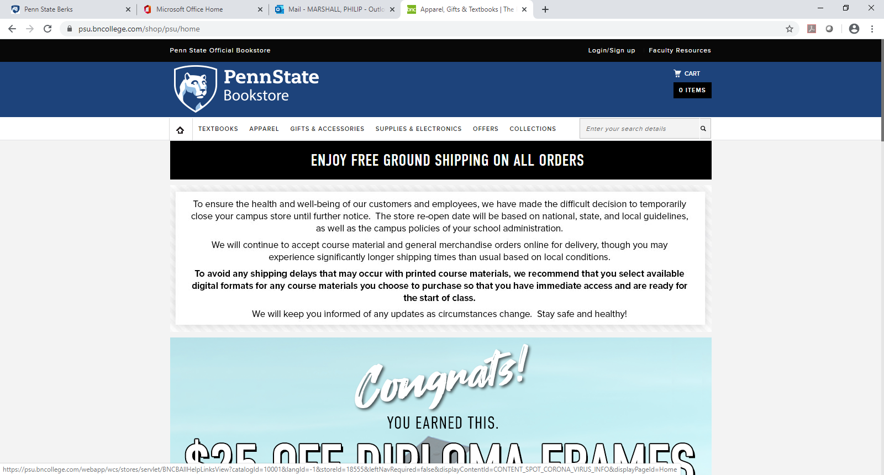
- In the top left corner, you will find a tab, TEXTBOOKS, listed next to the home button, mouse over the TEXTBOOKS tab
- There will be a drop-down menu which appears. Select FIND TEXTBOOKS
- You will be taken to the screen: FIND COURSE MATERIALS
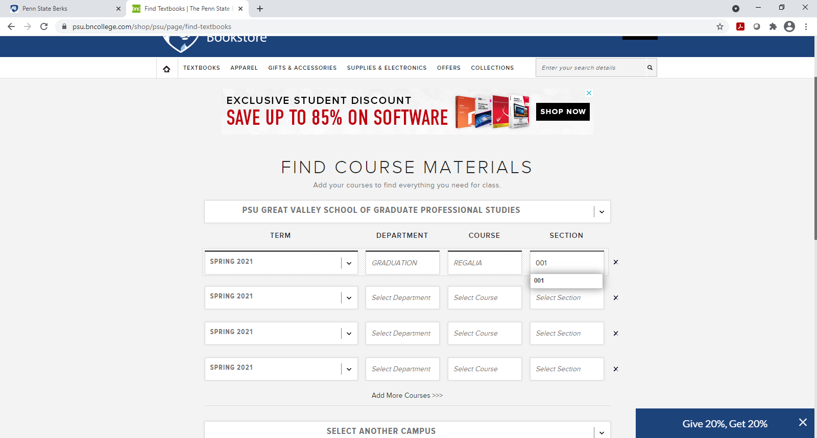

- Directly under the heading FIND COURSE MATERIALS is a drop-down menu box: SELECT A CAMPUS
- Select PSU GREAT VALLEY SCHOOL OF GRADUATE PROFESSIONAL STUDIES
- In the “TERM” menu box, select SPRING 2021 and move the cursor to the “DEPARTMENT” menu box
- In the “DEPARTMENT” menu box, you will select GRADUATION and move the cursor to the “COURSE” menu box
- In the “COURSE” menu box, you will select REGALIA from the drop menu, and move the cursor to the “SECTION” menu box
- In the “SECTION” menu box you will select the section “001”
- Upon entering this information, you will click the” FIND MATERIALS” command box at the bottom center of the page
- The web site will automatically provide the regalia information
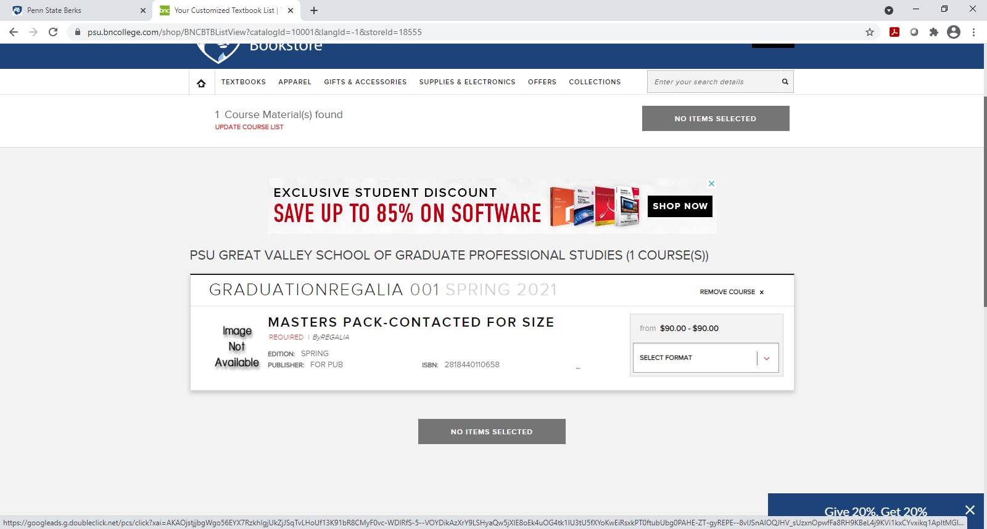

- Select your CAP AND GOWN PACKAGE (Master Package) on the right side under the heading “SELECT FORMAT”
- When done selecting please click the ADD ITEMS TO CART button
- Your SHOPPING CART will appear, and you can begin CHECKOUT or continue shopping
- You will want to enter in your shipping and billing information (create an account if you like)
- You will receive an initial EMAIL CONFIRMATION that your order has been submitted to the Bookstore.
- A Bookstore staff member will call the phone number listed to ensure proper height and weight sizing for your Cap, Hood and Gown
- You will receive a second EMAIL CONFIRMATION when your order has been processed and shipped or available for pick up
- Any questions please call our Bookstore at 610-648-3280. Our store hours are Monday through Thursday 11:30am-6pm and Friday 10am-2pm.

